Dear pastors and brothers, may the grace and mercy of our Lord and God be with you and yours.
Brothers, their prayers and help have been instruments that our Lord has used to carry forward much of our ministries and it is our duty to report to you how these ministries are being developed.
No.1- A few months ago I told you about our desire to build a small building to house a group of brothers in the community of Los Toros de Azua, where a church was started with three men of God who are being trained with us and had a Bible study. The photos you can see below show the level of this construction.
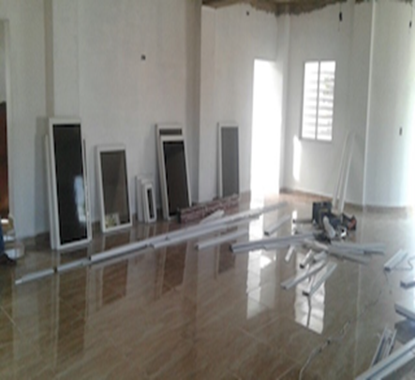
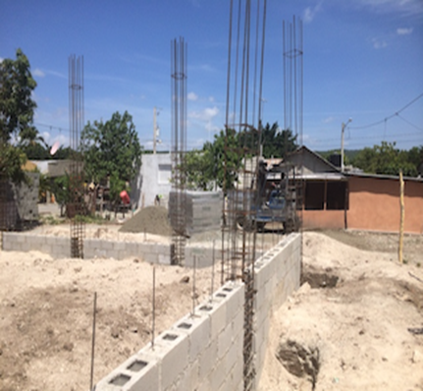

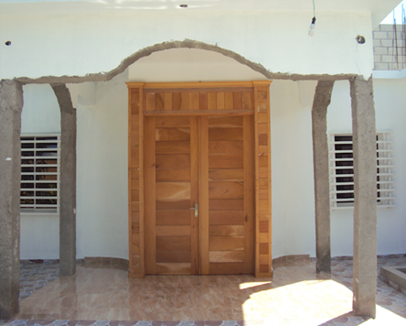
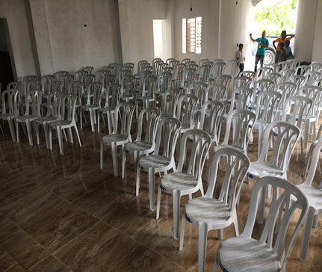

Already more than eighty adults are attending this church and soon we will have a baptism of fifteen new brothers. With this church there are three that we have been able to raise in the province of Azua. The other two are located in the Carrizal and Las Guanábanas communities. We are praying to the Lord for the church in Los Toros to become a pastoral training center for the whole South since many pastors in that region can´t come to our training in Santo Domingo and the church is at the center of the whole zone.
No.2- The Summer Bible School.
Last week, our Summer Bible School was attended by more than 300 children from the communities near our church. We were really surprised this year with the number of children who came from dysfunctional homes. Working with these children and adolescents was very difficult, but our Lord gave us the strength and grace to do it. Brothers, it is sad to hear the level of promiscuity that many of these adolescents are living, but they have no other example in their homes. We thank the Lord for the place where he has put us to serve and we pray that in this place we will be true light and true salt.
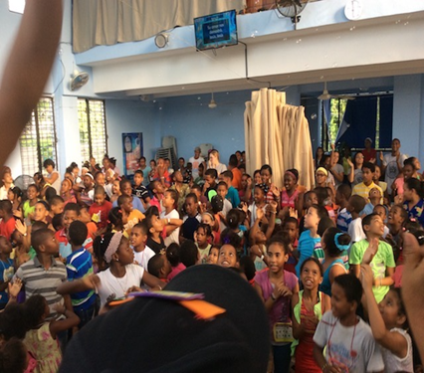
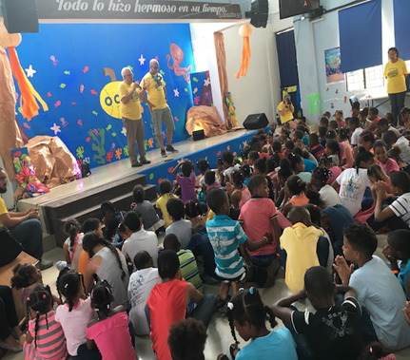
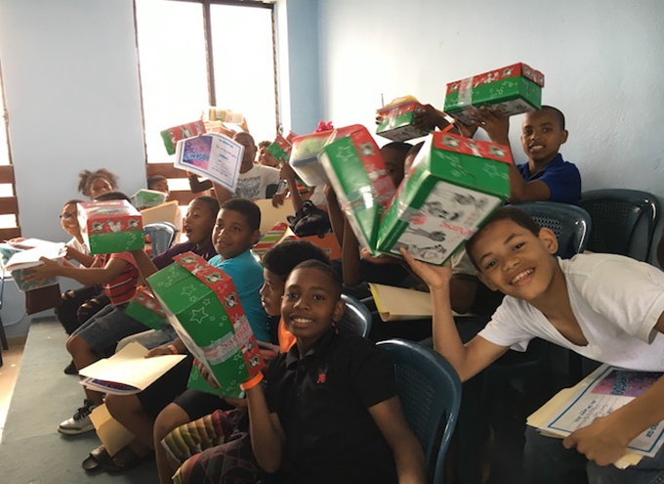

No.3- Pastoral training.
We want to inform you that as regards the training of pastors and leaders, the Lord has blessed us so much that we have surpassed the capacity of our church. In some trainings we have an attendance of more than 150 pastors and leaders and many more pastors and leaders want us to allow them to attend. Glory be to our Lord.
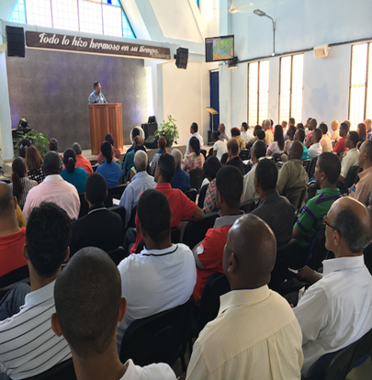
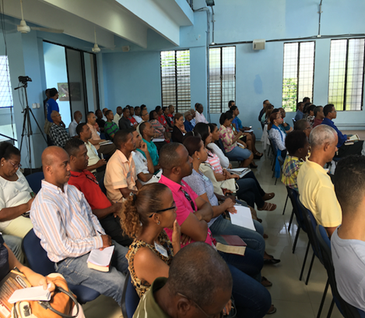
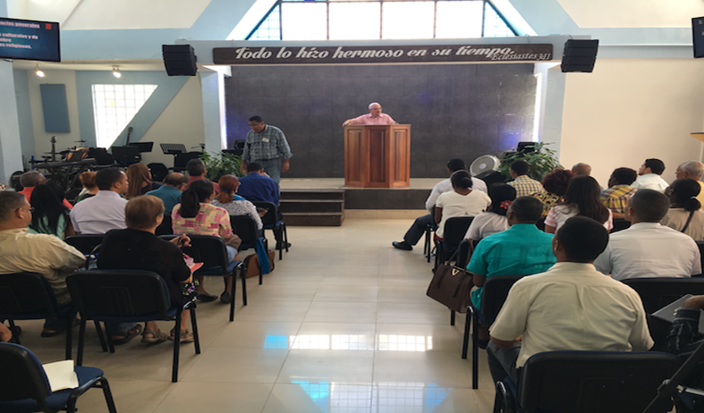
Dear pastors and brothers, we want to give glory to our Lord and God for having used it as instruments for the work to be carried forward. We pray to our Lord that He will reward them according to His immense mercies.
Reason for Prayer:
We want you to pray that our Lord will continue to help us prepare more leaders and pastors who know the Gospel of grace well. There is a great ignorance of the Word of God in the minds of most of our nation's churches.
Also so that the Lord continues giving us grace in front of the pastors and leaders that we are training.
For all these children and teenagers who heard the word of God, that the Lord may do the work in their hearts.
For the Church of Los Toros, Carrizal and Las Guanábanas, so that the Lord strengthens these men who are ministering in these places and be an example to many pastors of those communities. And for us, our Iglesia Fundamento Biblico for the Lord to keep us doing His will and to remember whenever we do everything is by His Grace and for His glory. To Him be the glory for ever and ever, Amen.
In the love of Christ, his servant, pastor Miguel Angel Castillo.

